Computing Vision
Lab Manual 5
Code:
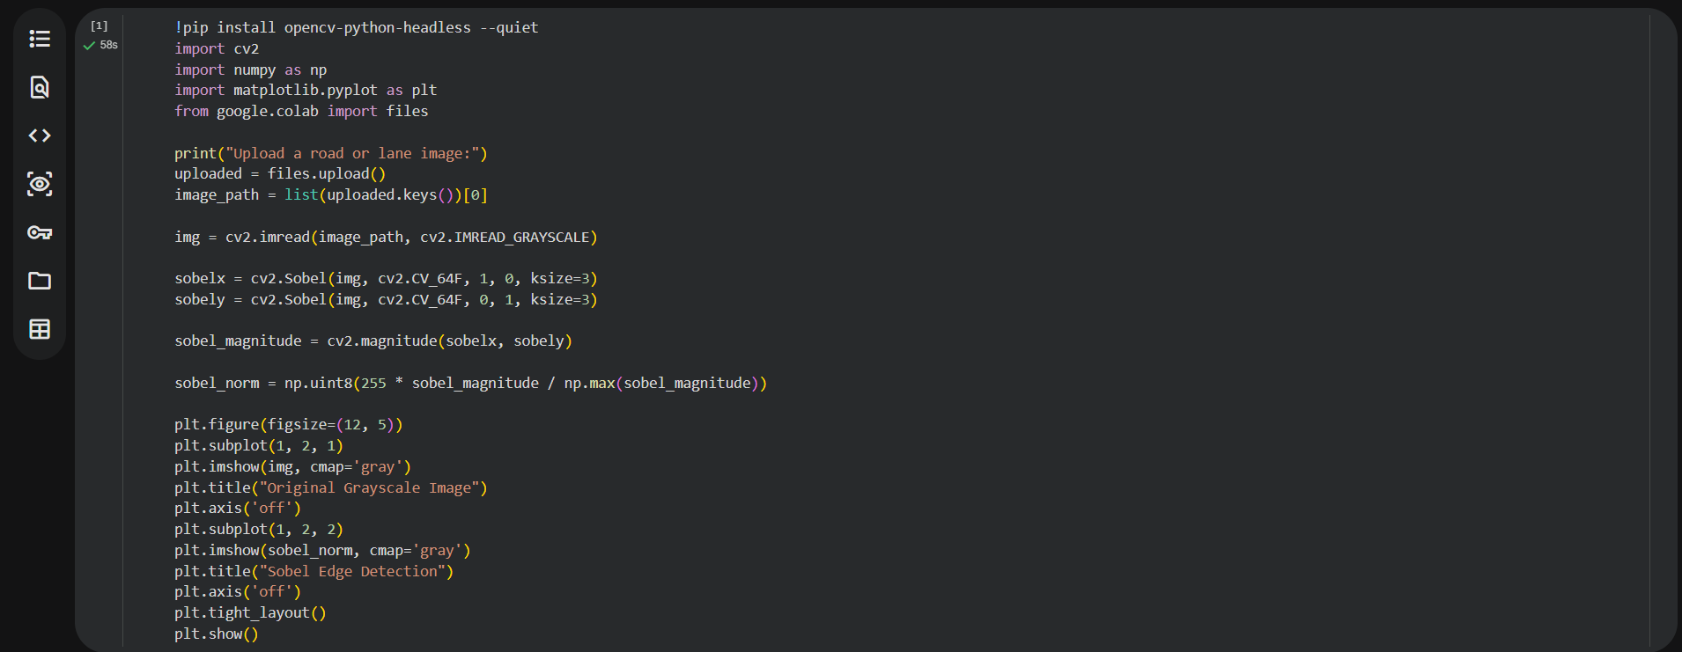

Output:
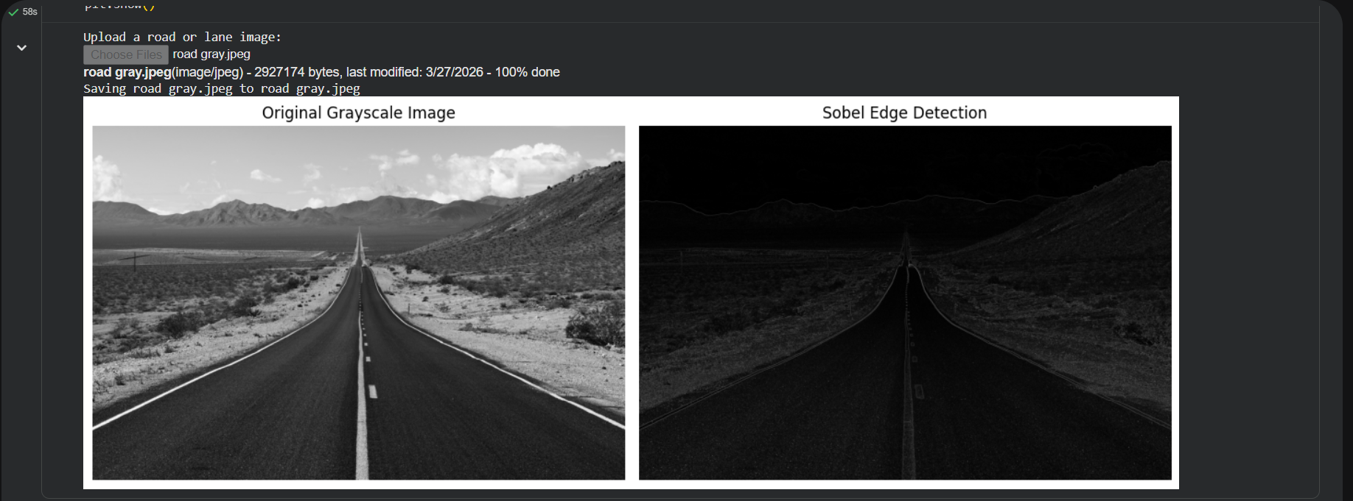
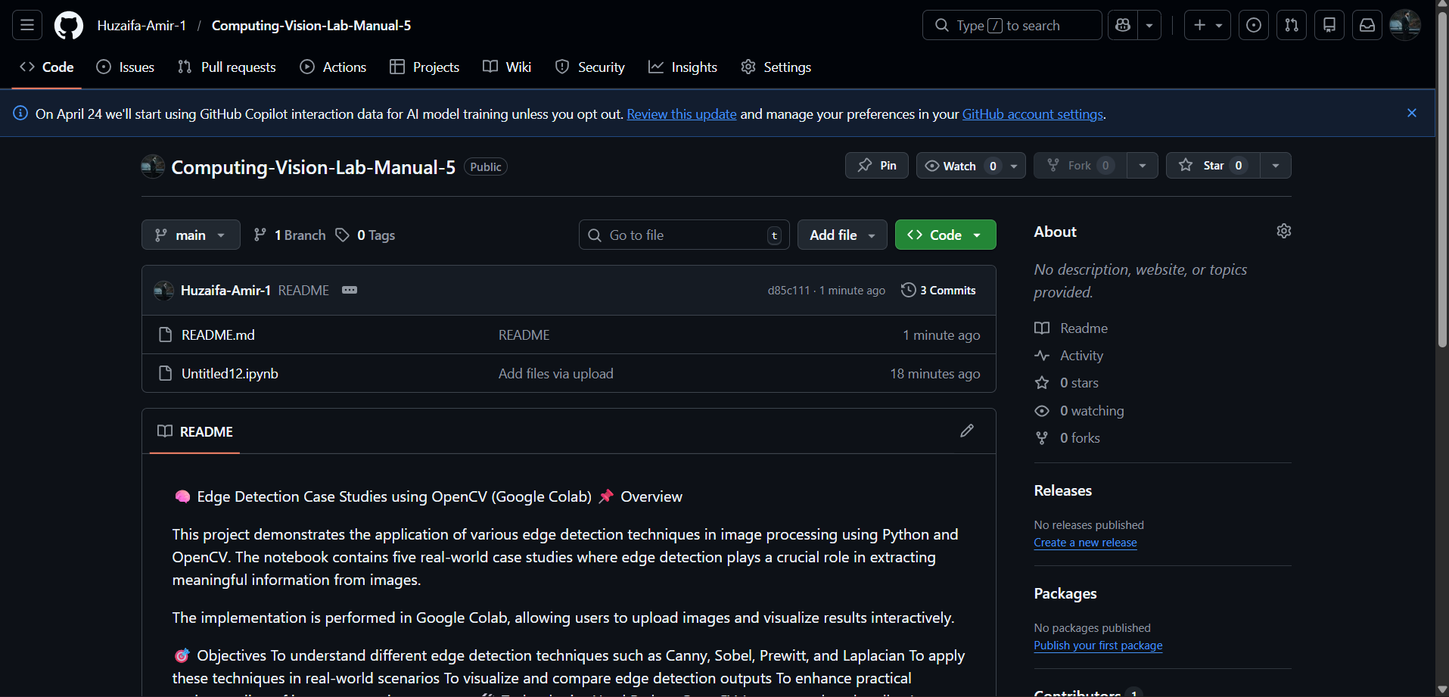
https://github.com/Huzaifa-Amir-1/Computing-Vision-Lab-Manual-5

